Top 12 Pay Per Click Affiliate Programs for SaaS in 2026
March 21, 2026
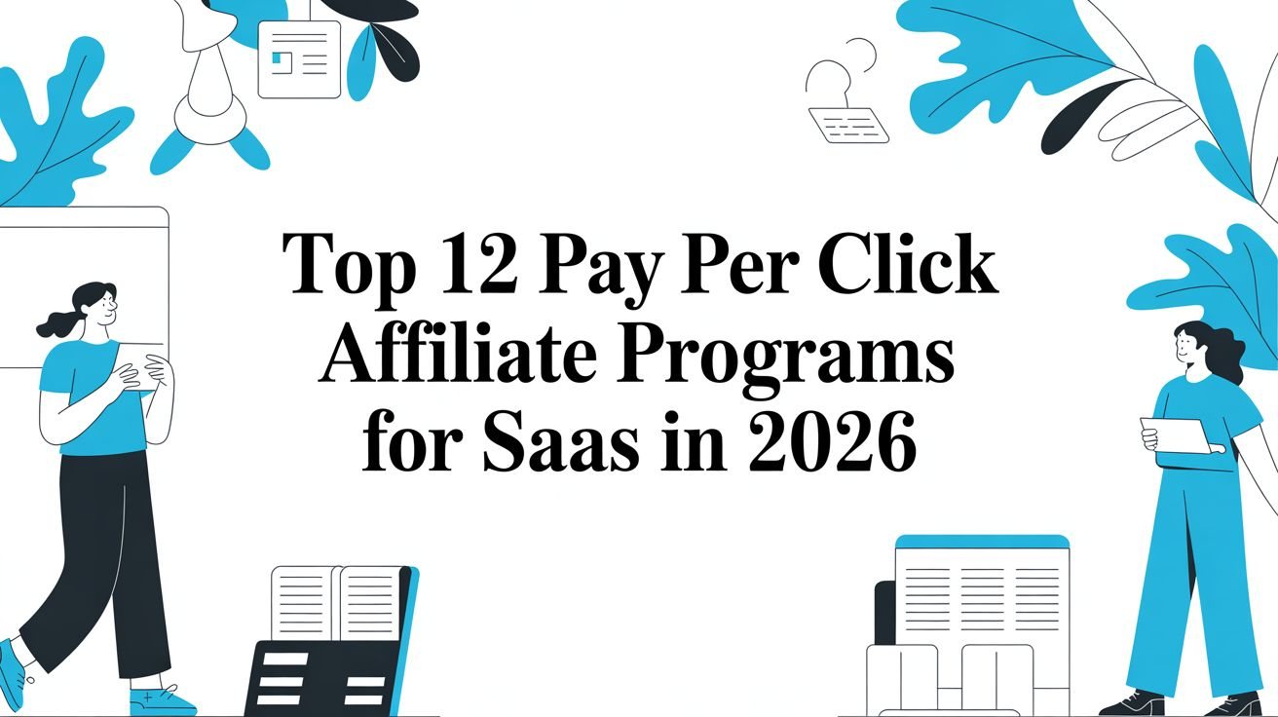
While Cost-Per-Sale (CPS) models often dominate affiliate marketing discussions, overlooking pay per click affiliate programs can be a costly mistake, especially for SaaS businesses. PPC programs offer a distinct advantage by rewarding partners for driving traffic, not just final sales. This model is perfect for building brand awareness, testing new traffic sources, and generating top-of-funnel interest without a high initial commitment. The power of pay per click lead generation for SaaS affiliate marketing lies in its ability to target users actively searching for solutions, creating a steady stream of potential customers.
This guide moves beyond generic lists to provide an actionable resource for SaaS founders, marketers, and developers. We'll explore 12 of the best PPC affiliate programs and networks, from established giants like the eBay Partner Network to content-focused platforms like Sovrn and native ad networks such as Taboola. Each entry includes a detailed breakdown of:
- Payout models and typical earnings
- Approval requirements and traffic quality standards
- Potential for click fraud and mitigation tactics
- Strategic guidance on when to use PPC versus CPS or CPL
We’ve done the research, providing direct links and honest assessments to help you find the right platform for your SaaS growth strategy. Let's get started.

1. Refgrow
Refgrow stands out as a premier choice for SaaS and digital product companies aiming to build a truly native affiliate program without the typical high costs or revenue-sharing models. It's an embed-first platform designed to integrate an affiliate dashboard directly into your application's user interface. This approach eliminates disruptive redirects to external portals, keeping your affiliates engaged within your own product ecosystem and boosting conversion potential. The entire experience, from signup to tracking performance, feels like a core part of your app, not a bolted-on third-party tool.
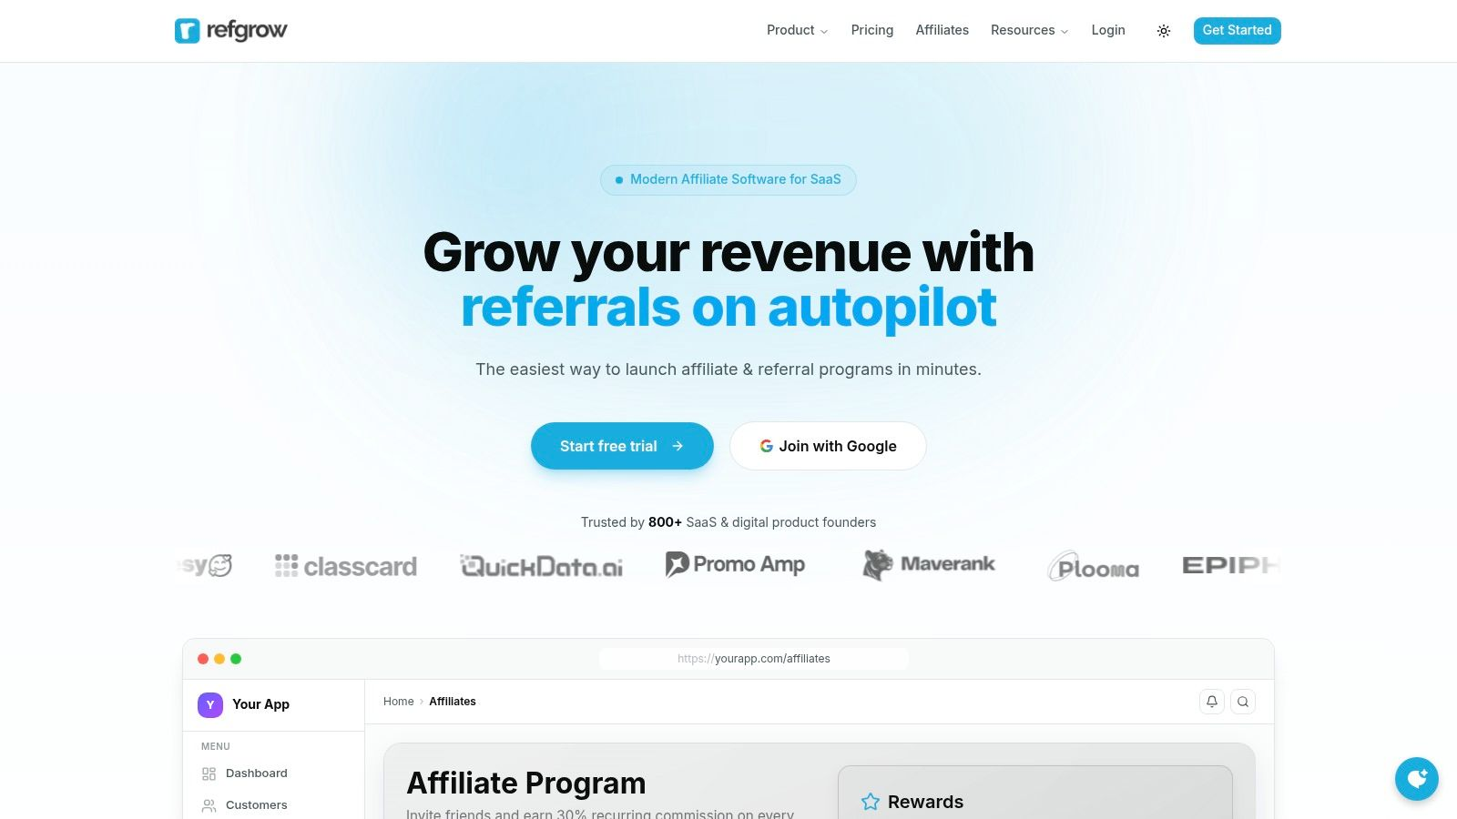
What makes Refgrow a strong contender in the pay per click affiliate programs space is its combination of an enterprise-grade feature set with startup-friendly pricing. You gain access to advanced commission structures, multi-language support, and real-time analytics, all while avoiding the percentage-based fees that penalize growth. For developers and CTOs, the simple script tag installation, robust API, and webhooks provide a fast, flexible, and low-maintenance solution. Meanwhile, founders and growth teams benefit from the Referral Exchange, which supplies pre-vetted partners to kickstart affiliate acquisition from day one.

Key Features and Use Cases
- Native In-App Experience: A single JavaScript snippet embeds a fully brandable affiliate widget inside your product. This is ideal for SaaS founders who prioritize a seamless user experience and want to avoid sending users to external login pages.
- Cost-Effective Scaling: With plans starting at $29/month and 0% transaction fees, it's built for businesses that want predictable costs. You can scale your affiliate revenue without your software bill scaling alongside it.
- Advanced Commission Automation: Set up complex commission rules, including per-affiliate, per-product, multi-tier, and performance-based rewards. This is perfect for motivating top performers or structuring a multi-level marketing (MLM) style program.
- Developer-First Integrations: With a REST API, webhooks, and an MCP Server, Refgrow allows for deep automation. A common use case is connecting it to your internal CRM or building custom AI agent workflows to manage affiliate communications.
- Rapid Partner Acquisition: The exclusive Referral Exchange connects you with a network of vetted affiliates, helping you bypass the slow process of cold outreach and start generating clicks and signups immediately.

Analysis
Feature | Refgrow | Typical Alternatives
Pricing Model | Flat monthly fee (starts at $29/mo), 0% transaction fees. | Often charge a percentage of affiliate-driven revenue, increasing costs as you grow.
User Experience (UX) | Embedded, native in-app widget. Affiliates manage everything inside your product. | Usually requires an external, separately branded affiliate portal with its own login.
Setup & Integration | Fast setup with a single script tag. Integrates with Stripe, Paddle, Lemon Squeezy. Free migrations offered. | Can require more complex engineering work and may not offer free migration support.
Fraud Risk Mitigation | Provides real-time click and conversion analytics, allowing for close monitoring of traffic quality. You control affiliate approval. | Varies; larger networks may have automated tools but can be less transparent.
Best For | SaaS founders, growth teams, and CTOs needing a low-cost, developer-friendly, and highly customizable affiliate program that maintains brand consistency. | Companies that prefer a massive, pre-existing affiliate marketplace and are willing to pay for it.
Limitations | The Referral Exchange is a curated network, not a massive open marketplace. Full white-labeling is reserved for higher-tier plans. | Can have clunky UIs and less flexible branding options. The revenue-share model is a major drawback.
Website: https://refgrow.com

2. eBay Partner Network (EPN)
While primarily known for its cost-per-sale (CPS) model, the eBay Partner Network (EPN) offers a unique, discretionary pay-per-click option for high-quality partners. This makes it a noteworthy contender among pay per click affiliate programs for established publishers with consistent, valuable traffic. The main draw is monetizing clicks that don't immediately convert, a feature many retail affiliate programs lack.
EPN's strength lies in its trusted global marketplace. Your audience is more likely to click through to a familiar brand like eBay, increasing your potential earnings. For those not eligible for the CPC rate card, the traditional CPS model still provides a solid revenue stream across an immense product catalog.

Approval and Implementation
- Approval: Access to the CPC program is discretionary and typically reserved for partners who demonstrate significant traffic volume and quality. All other approved affiliates default to the CPS/CPA model.
- Implementation: The partner portal provides robust reporting tools and a variety of linking options, including APIs for custom integrations.
The platform is best for publishers whose niche aligns with eBay's diverse categories, from electronics to fashion. While CPC isn't guaranteed, the sheer scale of the marketplace and brand recognition make EPN a valuable tool. For those new to the field and looking to build a foundation before applying to programs like EPN, getting started in affiliate marketing requires understanding these different payout models.
Website: eBay Partner Network

3. ShopYourLikes (Connexity)
ShopYourLikes, powered by Connexity, is a platform built specifically for social media creators and influencers. It operates on a pure pay-per-click model, allowing creators to earn revenue when their followers click on monetized links to participating retailers. This makes it one of the most direct pay per click affiliate programs for those with engaged audiences on platforms like Instagram and TikTok, as it removes the dependency on a final sale.
The platform is optimized for social media placements and offers access to a broad range of mainstream US retailers in fashion, beauty, and home goods through Connexity's network. This focus on immediate click monetization offers a fast path to earnings for creators whose content drives high engagement and outbound traffic.
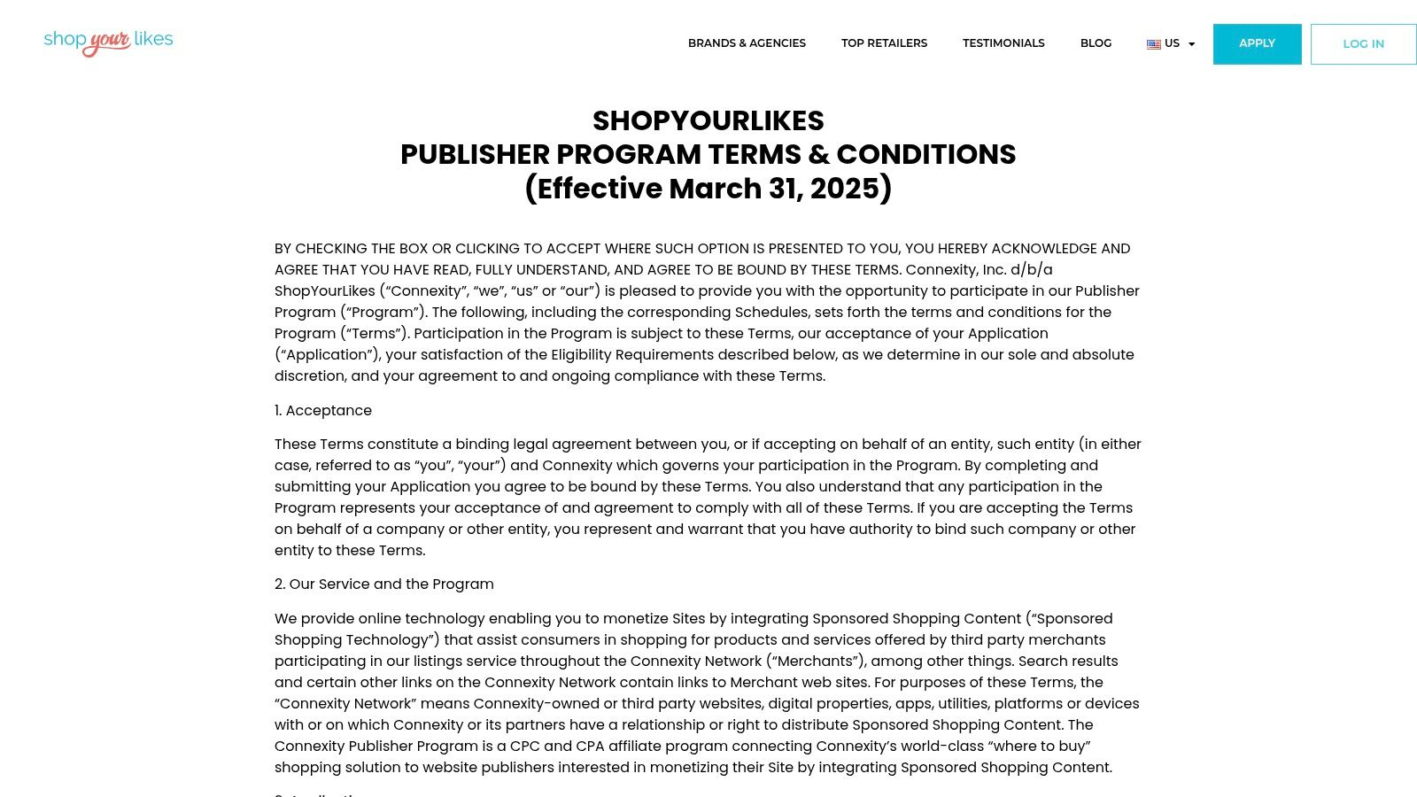

Approval and Implementation
- Approval: The program is designed for social media creators and requires an application. Approval is contingent on having an active, public social media profile that meets their quality guidelines.
- Implementation: Once approved, creators gain access to a portal to generate monetized links. The platform has strict policies against incentivizing clicks and specific rules about link placement to ensure high-quality traffic for its retail partners.
ShopYourLikes is ideal for influencers in popular retail niches who can generate a high volume of qualified clicks from their content. While there are minimum payout thresholds and payment method constraints, its social-first approach and CPC model present a strong opportunity for content creators to monetize their influence without relying on conversions.
Website: ShopYourLikes

4. Sovrn Commerce (formerly VigLink)
Sovrn Commerce streamlines monetization by automatically converting standard outbound product links into commissionable affiliate links. This platform is a powerful tool for publishers who want to earn from traffic without manually joining dozens of programs, offering a mix of CPC and CPA models. Its standout feature is link optimization, which can route clicks to the highest-earning merchant, making it one of the more efficient pay per click affiliate programs for content-rich sites.
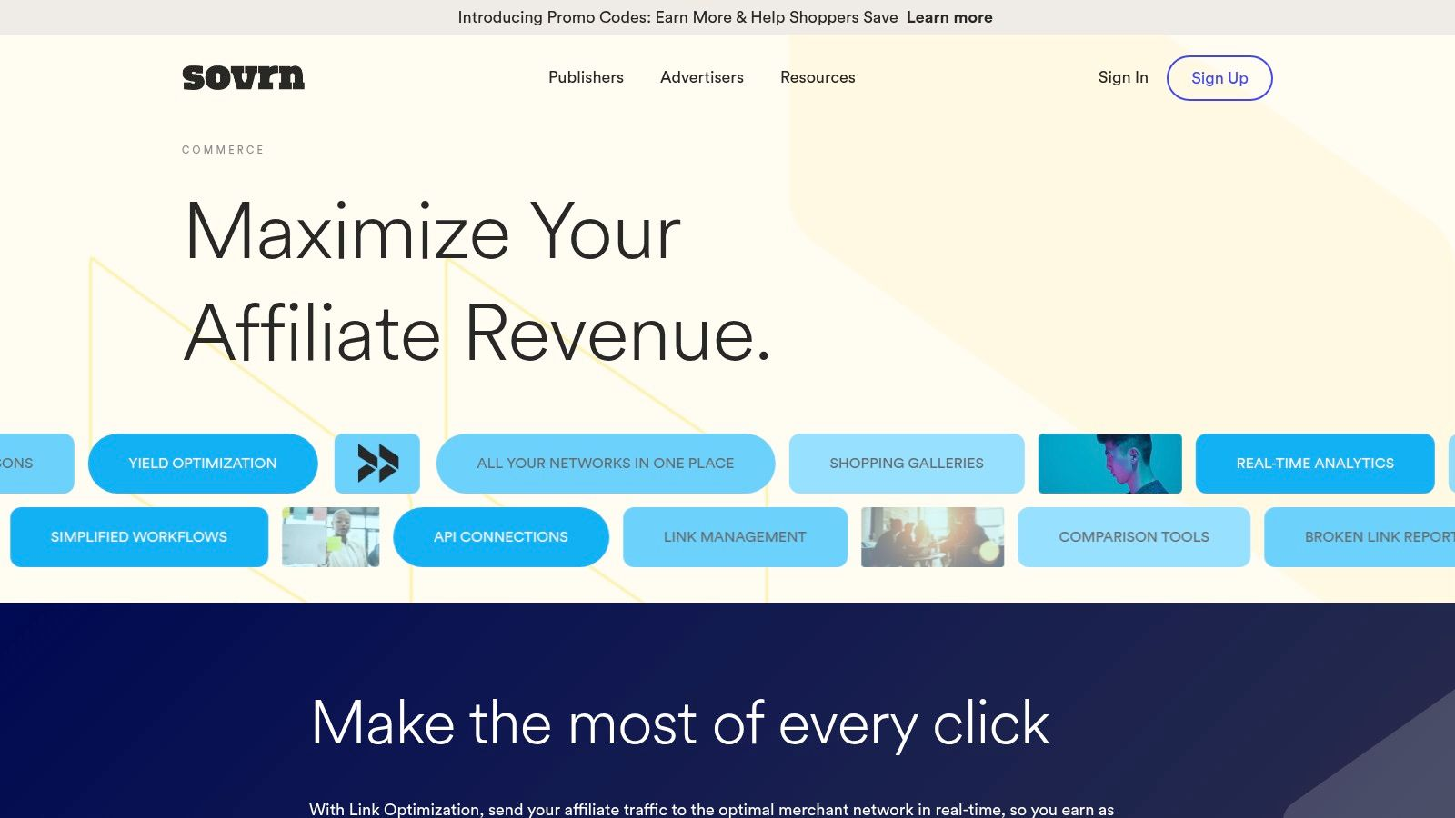
This automated approach is especially useful for earning revenue from clicks that don't result in an immediate sale, a common scenario for publishers focused on discovery and browsing. The system handles the complexity of finding and applying the best commission type, whether it's CPC or CPA, on a per-click basis.

Approval and Implementation
- Approval: Sovrn has a straightforward approval process. Once your site is accepted, you gain access to its entire network of tens of thousands of merchants. The platform's onboarding is designed to surface CPC-first merchants to new creators.
- Implementation: Setup involves adding a small snippet of JavaScript to your site. This code then dynamically converts your links. For those wanting more control, manual link-building tools are also available.
Sovrn is best for bloggers and content creators who link to a wide variety of products and want a low-maintenance solution. While payment timing can vary based on merchant schedules, the automated optimization and broad merchant access offer significant value. Properly monitoring this performance requires understanding the best affiliate tracking software to ensure accurate attribution.
Website: Sovrn Commerce

5. Skimlinks
Skimlinks operates as a content monetization platform, automatically converting existing product links in your content into affiliate links. While primarily a CPA-focused network, its connection with Connexity (a major shopping-focused advertising network) provides access to CPC revenue streams, placing it among viable pay per click affiliate programs for content-heavy sites. This makes it an ideal, hands-off solution for publishers who want to monetize their entire site without manually joining hundreds of individual programs.
The platform’s core strength is its scale and simplicity. With a single piece of code, you gain access to over 48,500 merchants. It excels for blogs, forums, and editorial sites where product mentions are frequent but not always pre-linked. Skimlinks finds these opportunities and monetizes them, pooling your earnings from various merchants into a single payment.

Approval and Implementation
- Approval: The approval process is straightforward. Publishers apply, and Skimlinks reviews the site for quality content and traffic. Once approved, you get access to the entire network.
- Implementation: Implementation involves adding a JavaScript snippet to your website's header or footer. The system then works in the background, requiring no further technical effort to convert links.
Skimlinks is best suited for publishers who prioritize automation and breadth over granular control of individual merchant relationships. It is a powerful tool for capturing revenue from organic content that might otherwise go unmonetized.
Website: Skimlinks

6. Media.net
As one of the largest contextual advertising networks globally, Media.net is a formidable AdSense alternative that gives publishers access to the vast Yahoo! Bing Network search demand. It's a key player among pay per click affiliate programs because it automatically optimizes ad units to serve the highest-yielding format, whether that's CPC, CPM, or CPA. This dynamic allocation helps publishers maximize revenue from their ad inventory without manual intervention.
The platform is particularly strong for websites with a high volume of traffic from the US, UK, and Canada. Its contextual ad units blend well with content, leading to higher engagement and click-through rates compared to standard banner ads. This makes it an excellent monetization layer to run alongside other affiliate or direct-sold campaigns.


Approval and Implementation
- Approval: Media.net requires an application and manual review. They look for high-quality, original content, a professional site design, and a significant portion of traffic from top-tier countries.
- Implementation: Publishers add a single ad tag to their site. The dashboard provides controls for ad customization and performance monitoring. Dedicated account managers are often assigned to help with optimization.
Media.net is best suited for established content creators and bloggers whose primary audience is in North America. While revenue share terms are account-specific and not public, its strong contextual engine and access to unique search demand make it a powerful tool. For publishers building their traffic, focusing on content that attracts a US audience is a solid strategy before applying.
Website: Media.net

7. Revcontent
Revcontent is a content recommendation network that primarily functions on a pay-per-click model, offering publishers a way to monetize their audience's engagement. Instead of traditional banner ads, it places native ad widgets, often at the end of articles, that blend with the site's content. This focus makes it a strong candidate for publishers looking for reliable pay per click affiliate programs that reward engaged readership.
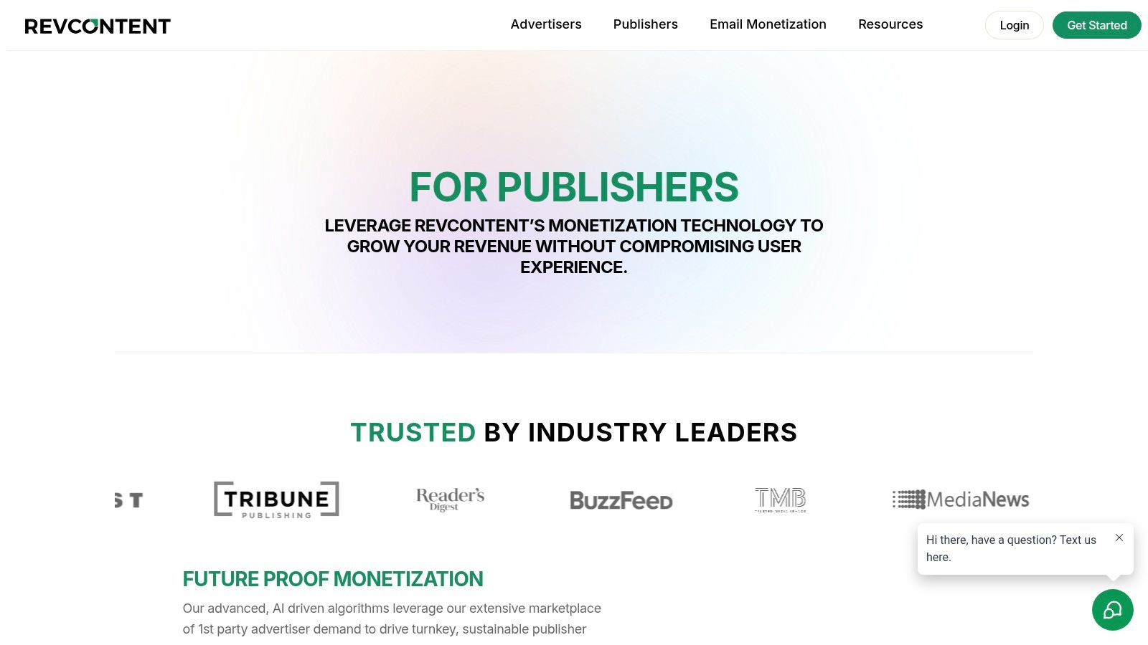
The platform’s strength is its CPC-centric approach, directly tying a publisher's revenue to user clicks. This differs from many networks that prioritize conversions (CPA/CPS). Revcontent can also run alongside other ad solutions, like AdSense, allowing for a diversified monetization strategy. The hands-on optimization guidance helps publishers maximize their widget performance and click-through rates.

Approval and Implementation
- Approval: The application process is selective. Publishers typically need to demonstrate consistent, high-quality traffic to be accepted, and a minimum payout threshold is in place.
- Implementation: Once approved, publishers gain access to a self-serve portal with various native ad widgets and robust analytics. Implementation involves placing a small code snippet on your website.
Revcontent is best suited for established content sites and blogs with a substantial, engaged audience. While some third-party reviews mention inconsistent support or payout experiences, its core CPC model and ability to supplement other revenue streams make it a worthwhile option for high-traffic publishers.
Website: Revcontent for Publishers

8. Taboola
Taboola operates as a premier native advertising network, offering a powerful avenue for publishers to monetize their traffic through a CPC model. While not a traditional affiliate program, its system allows publishers to earn revenue for every click on sponsored content, making it a key player in the world of pay per click affiliate programs. High-traffic websites with quality content can earn significant income by displaying Taboola’s content-recommendation widgets.
The network’s strength comes from its massive advertiser demand and sophisticated optimization tools. Advertisers bid for placements on premium news and media sites, and Taboola’s AI-driven platform optimizes ad delivery for maximum engagement and revenue. This creates a competitive environment where clicks on your site can generate consistent returns.
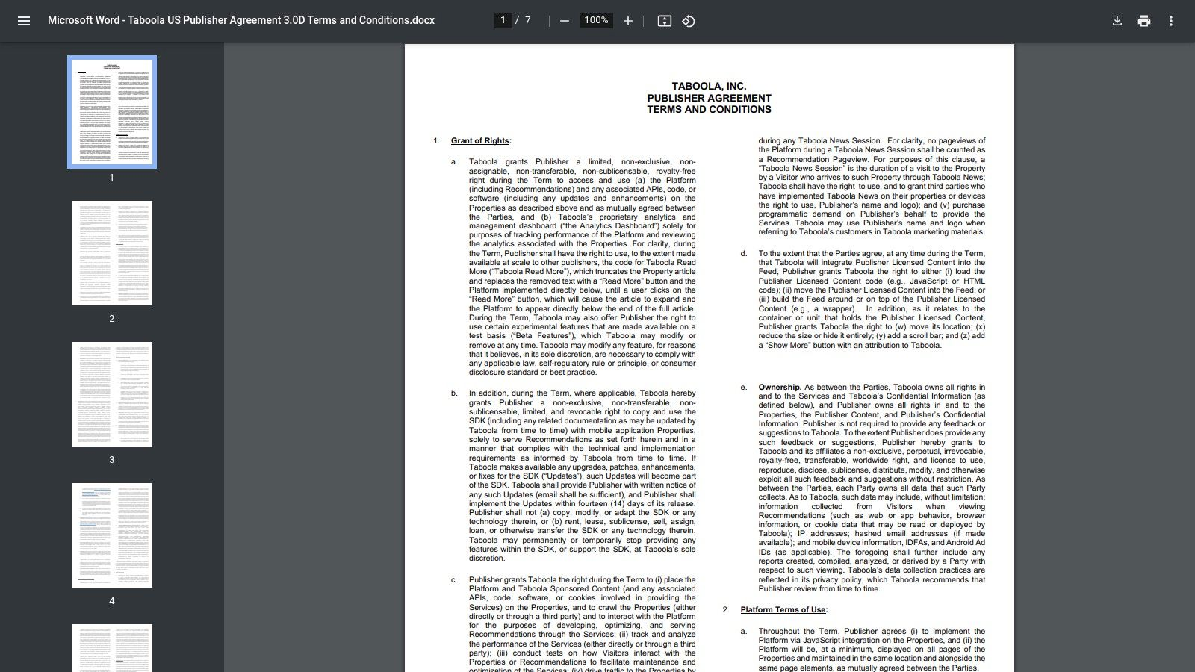

Approval and Implementation
- Approval: Taboola maintains strict publisher policies and typically favors larger publishers with significant, consistent traffic. There are minimum traffic thresholds and content quality bars that must be met for approval.
- Implementation: Once approved, implementation involves adding a code snippet to your site. The platform provides granular controls, including Enhanced CPC and per-publisher bid modifiers, to manage ad experience and revenue.
Taboola is best for established content creators and media properties that can meet its quality standards. For those new to this revenue model, understanding the fundamentals of how performance is measured is crucial; you can learn more about what is performance marketing to get a better grasp of the concepts. While it requires monitoring to maintain a positive user experience, the revenue potential is substantial.
Website: Taboola Publisher Agreement

9. MGID
MGID operates as a global native advertising network, offering a strong pay-per-click model that makes it an excellent choice for publishers with diverse international traffic. Unlike platforms focused solely on top-tier geos, MGID provides a self-serve CPC flow designed to monetize audiences across many geographies and verticals. This makes it one of the more flexible pay per click affiliate programs for sites that don't rely exclusively on US or Western European visitors.
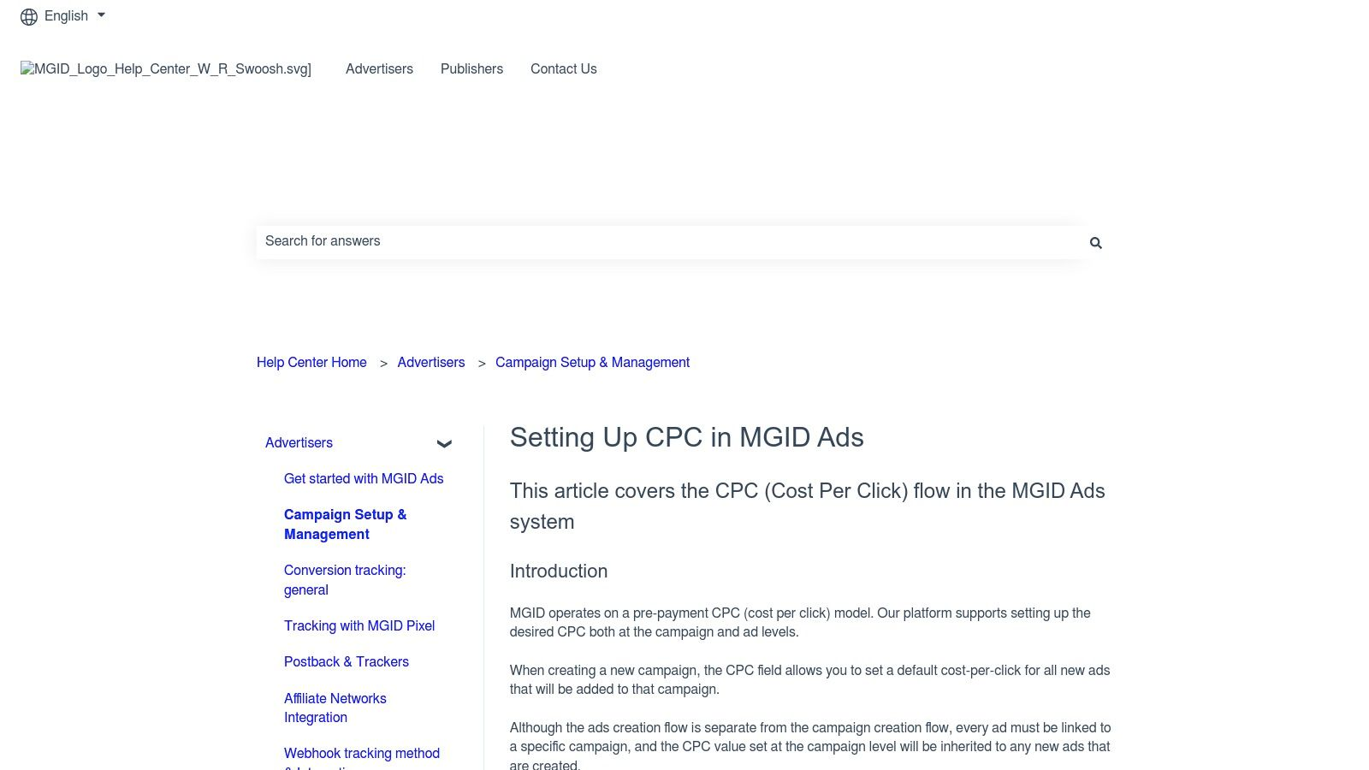
The platform's key advantage is its blend of CPC and geo-diverse demand, allowing publishers to generate revenue from clicks originating anywhere. Its transparent documentation and straightforward platform workflows simplify the process of setting up and managing ad placements. However, performance can vary by niche, requiring active management to optimize earnings.

Approval and Implementation
- Approval: MGID maintains quality standards and has publisher acceptance thresholds. While not as stringent as some premium networks, very new sites with low traffic may not be approved immediately. The onboarding process includes standard KYC (Know Your Customer) checks.
- Implementation: The platform provides widgets and ad placement tools that are easy to integrate. Publishers have control over CPC bidding and can access detailed reporting to monitor performance across different placements and regions.
MGID is best for mid-sized publishers looking to monetize a global audience through native ads. The need for active placement management means it's a better fit for those willing to test and adjust their strategy for optimal results.
Website: MGID Help Center

10. Adsterra
Adsterra operates as a global advertising network that offers publishers a straightforward path to monetization, making it a viable option among pay per click affiliate programs. It supports a wide array of payout models, including CPC, CPM, and CPA, across multiple ad formats like display, native, and push notifications. This flexibility allows publishers to experiment and find the most profitable setup for their audience and content type.
The platform's main advantage is its accessibility. Adsterra is known for its low entry barriers, welcoming new publishers and sites with smaller traffic volumes. This makes it an excellent starting point for those who may not yet qualify for more restrictive, high-tier networks. Its user-friendly interface and guidance on optimizing rates based on geography and ad format help newcomers get up and running quickly.

Approval and Implementation
- Approval: The approval process is generally fast and accommodating for a broad spectrum of websites, including brand-new blogs and content sites.
- Implementation: Publishers gain access to a self-service platform to generate ad code. The system is designed for quick integration, often requiring just a simple copy-and-paste action to start displaying ads.
While Adsterra provides an accessible entry into CPC, publishers must monitor ad quality and user experience. Some of the more aggressive formats, like pop-unders, can be intrusive. Understanding the different monetization strategies is key, and exploring the various types of affiliate marketing can provide context for choosing the right model for your site.
Website: Adsterra

11. Bidvertiser
Bidvertiser is a direct advertising network that offers one of the most straightforward pay per click affiliate programs available, making it highly accessible for new and independent publishers. It operates on a true PPC model where you earn for every valid click on the ads displayed on your site, without requiring a final sale or lead conversion. This model is perfect for monetizing general traffic that might not convert through a traditional CPS offer.
What sets Bidvertiser apart for smaller sites is its quick approval process and exceptionally low payment threshold. This accessibility allows publishers to start earning almost immediately, a significant advantage over more selective, high-traffic networks. The platform supports various ad formats, including banners, pop-unders, and native ads, giving you control over how you integrate monetization.

Approval and Implementation
- Approval: The approval process is known for being fast and inclusive, making it suitable for websites that are still growing their audience.
- Implementation: Publishers get access to a dashboard to generate ad code, track performance per ad spot, and customize ad appearance. The minimum payout is just $10 via PayPal, paid on a net-30 basis.
Bidvertiser is ideal for publishers who need a reliable PPC income stream without strict traffic requirements. While the CPC rates may be lower than premium networks, the ease of entry and consistent payment model provide a solid foundation for site monetization.
Website: Bidvertiser

12. Infolinks
Infolinks offers a different approach to website monetization by turning your content itself into ad inventory. It's a contextual ad network that automatically places targeted ads within your text (InText), on the edges of the screen (InFrame), and through other non-traditional units. This makes it a viable option for those exploring pay per click affiliate programs, as it provides a way to generate revenue from user engagement without relying on standard banner ads.
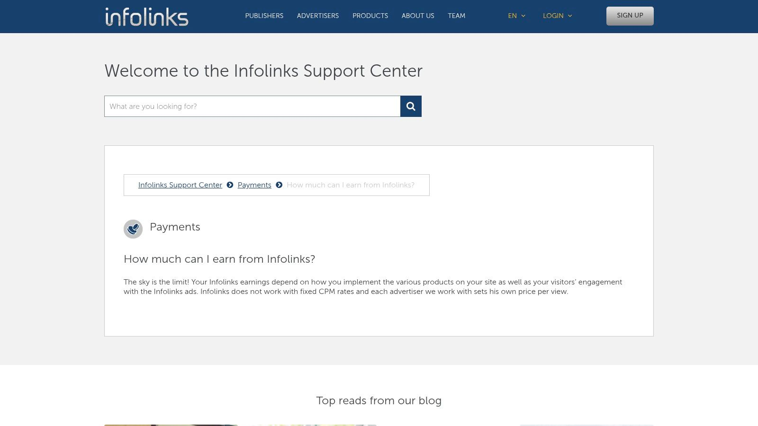
Its main benefit is simplicity and its ability to act as a supplemental income stream alongside other monetization platforms like AdSense. Because the ads are contextual, they can be highly relevant to the reader, potentially leading to better click-through rates. However, earnings can be unpredictable and are heavily dependent on your traffic's quality and niche.

Approval and Implementation
- Approval: Infolinks has a straightforward approval process with no minimum traffic requirements, making it accessible for newer or smaller websites. Approval is typically quick, often within 48 hours.
- Implementation: Adding the ad units to your site is as simple as inserting a single snippet of JavaScript code. The dashboard allows you to customize the ad types, color, and density to match your site's design.
Infolinks is best for content-heavy sites looking to add another layer of revenue without dedicating more ad space. While the visual intrusiveness can be a concern, careful customization can mitigate this, making it a useful tool for monetizing informational traffic that might not convert on traditional CPA offers.
Website: Infolinks

Top 12 Pay-Per-Click Affiliate Programs Comparison
Platform | Core features | UX / Quality (★) | Value & Pricing (💰) | Target Audience (👥) | Unique Selling Points (✨)
Refgrow 🏆 | Embed-first in-app widget, Stripe/Paddle/Lemon Squeezy integrations, REST API & webhooks | ★★★★★ native UX, real-time analytics | 💰 Starts $29/mo, 0% transaction fees, 14-day trial | 👥 SaaS founders, growth teams, CTOs | ✨ In-app white-label widget, Referral Exchange, advanced commission rules
eBay Partner Network (EPN) | CPS/CPA + discretionary CPC, global product catalog | ★★★★☆ robust partner reporting | 💰 CPS varies by category; CPC by approval | 👥 Publishers with retail/product traffic | ✨ Official eBay inventory; CPC option for select partners
ShopYourLikes (Connexity) | CPC for creator links, social placement tools | ★★★☆☆ creator-friendly UX | 💰 CPC payouts to creators | 👥 Social creators (IG/TikTok), fashion/beauty/home niches | ✨ Fast CPC path; Connexity retailer access
Sovrn Commerce | Auto-converts links, link optimization, CPC+CPA access | ★★★★☆ low-friction monetization | 💰 Centralized payouts (min $25); variable rates | 👥 Content publishers, bloggers | ✨ Auto-monetization + fallback routing to maximize EPC
Skimlinks | One-tag routing across 48,500+ advertisers, CPA/CPC support | ★★★★☆ hands-off scale | 💰 Revenue-share model; payout thresholds | 👥 Scalable content publishers | ✨ Massive advertiser footprint; Publisher Hub & tools
Media.net | Contextual CPC/CPM/CPA, Yahoo/Bing demand access | ★★★★☆ strong contextual targeting | 💰 Account-specific rev share terms | 👥 US/English content sites | ✨ Search-demand + single-tag yield optimization
Revcontent | Native recommendation widgets, CPC-focused marketplace | ★★★☆☆ selective approvals, optimization help | 💰 CPC revenue-share; min payout rules | 👥 Publishers with engaged audiences | ✨ Native widget placements with publisher guidance
Taboola | CPC bidding, AI distribution, strict quality controls | ★★★★☆ high-demand for premium sites | 💰 CPC marketplace; favors larger publishers | 👥 High-traffic news & media sites | ✨ Massive advertiser demand & fine-grained controls
MGID | CPC bidding, international reach, onboarding/KYC support | ★★★☆☆ geo-diverse monetization | 💰 CPC marketplace; performance varies by GEO | 👥 Mid-sized global publishers | ✨ Broad international coverage & partner support
Adsterra | CPC/CPM/CPA across display, native, interstitial, push | ★★★☆☆ flexible but some aggressive formats | 💰 Low thresholds; flexible payments | 👥 Small to mid publishers testing formats | ✨ Wide format coverage, easy setup
Bidvertiser | True PPC with multiple ad types, fast approvals | ★★★☆☆ accessible for new sites | 💰 Very low payout minimums (e.g., $10 PayPal) | 👥 New/independent publishers | ✨ Quick onboarding; true per-click payouts
Infolinks | In-text/in-frame contextual units, simple tag | ★★★☆☆ quick supplemental revenue | 💰 Lower thresholds; pay-per-view/click | 👥 Small publishers seeking add-on income | ✨ Simple contextual units that complement AdSense

Building a Smarter, Diversified Affiliate Strategy
Navigating the world of affiliate marketing reveals a clear truth: there is no single "best" program for every business. As we've explored, the options range from dedicated SaaS affiliate tools like Refgrow to expansive content monetization networks like Sovrn Commerce and native advertising giants such as Taboola and Revcontent. The right choice depends entirely on your specific business model, audience, and growth objectives. Pure pay-per-click affiliate programs are rare, especially for B2B SaaS, but hybrid models and PPC-adjacent platforms offer powerful alternatives for driving initial traffic and brand awareness.
The key takeaway is that a diversified approach is often the most resilient and effective. Relying on a single program, whether it’s CPS, CPL, or PPC, creates a single point of failure. By strategically layering different models, you can build a more robust acquisition engine.

Final Considerations for Your Affiliate Program
Before you commit, reflect on these critical points:
- Match the Model to Your Goal: If you need to generate top-of-funnel interest and can tolerate a lower conversion-to-click ratio, platforms like Media.net or even MGID can be a starting point. For B2B SaaS focused on qualified leads and eventual sales, a CPL or CPS model, perhaps managed through a tool like Refgrow that simplifies tracking, is a more sustainable path.
- Acknowledge the Risks: Click fraud is not a hypothetical threat; it’s an operational reality with PPC models. The lower the barrier to entry for affiliates, as seen with programs like Bidvertiser or Adsterra, the higher the risk. You must have fraud detection systems and diligent monitoring in place from day one.
- Integrate and Automate: Your time is best spent on strategy, not manual payout calculations. Prioritize programs and tools that integrate smoothly with your existing stack, especially your payment processor (Stripe, Paddle) and CRM. Automation frees you to focus on recruiting high-quality partners.
Ultimately, building a successful affiliate channel is an exercise in experimentation and measurement. To effectively build a diversified affiliate strategy, understanding the landscape of performance-based marketing is crucial. If you're looking for a deeper dive into this area, learning more about What Is a Performance Based Marketing Agency can provide valuable context on structuring deals and measuring success.
Your journey with pay per click affiliate programs and other performance models is a marathon, not a sprint. Start with a clear hypothesis, test a program that aligns with it, measure the results honestly, and be ready to pivot. The most successful affiliate strategies are not static; they are dynamic ecosystems that adapt to new partners, changing market conditions, and evolving business goals.

